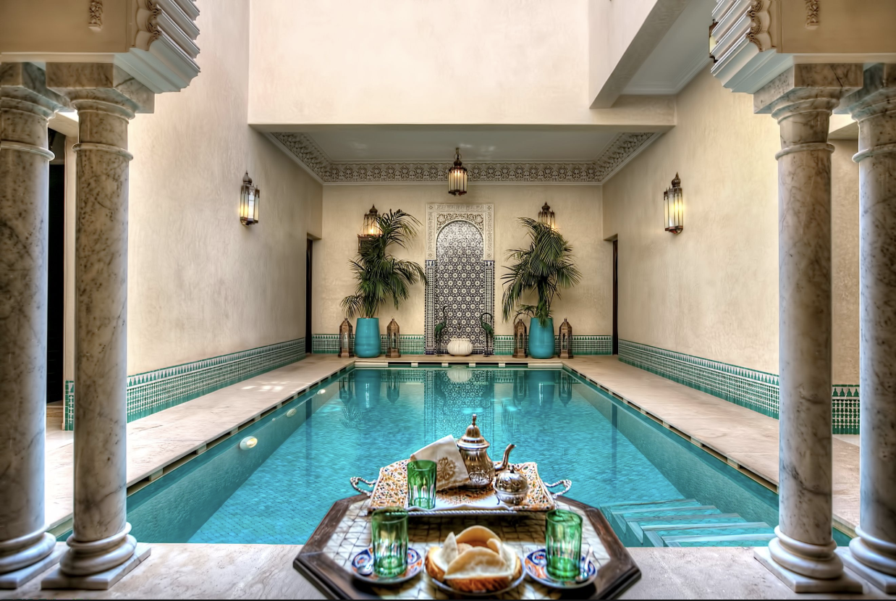

Sue Sheats
703-967-9336
sue@worldexposures.com
Imperial Cities of Morocco

February 19-26, 2020
Morocco is like a tree nourished by roots deep in the soils of Africa which
breathes through foliage rustling to the winds of Europe. | King Hassan II

Touching hearts and minds…
PM at leisure
Day.6 : AM Experience the Wonders of the Souks
Day 5: Go Berbere in the Atlas Mountains
Laurent Museum
PM Majorelle Garden & Yves Saint
Day 4: AM Hidden sides tour of Marrakech
Day 3 : Fez to Marrakech via Beni mellal
Day 2 : Full day in Fez
Volubilis & Meknes
Day 1 : Arrival to Casablanca – Rabat to Fez via

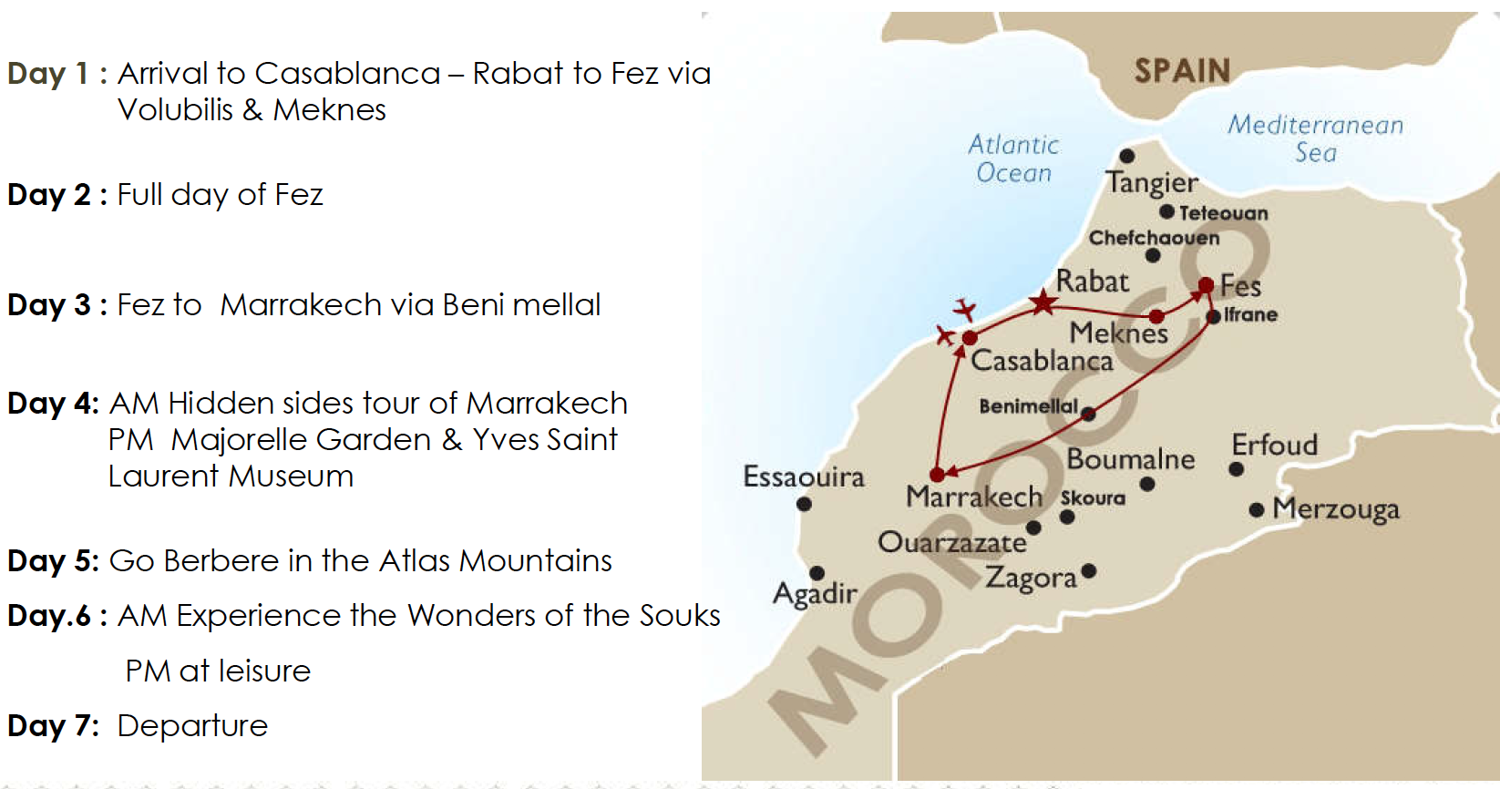
zz
Touching hearts and minds…
Overnight in Fez.
In the afternoon you have 3h30mn drive in a very relaxing motorway to Fez.
Lunch at Rick’s Café .
works in stained glass accomplished by a French artist in the mid 1950’s.
Visit the largest church in Casablanca, “Notre Dame De Lourdes”, where you will discover one of the most impressive
and the court of justice built in 1930’s.
squares of Casablanca, to admire the neo-Moorish style architecture of several official buildings such as the town hall
Visit Le “Marché Central”, the French food and flower market, before you stop on Mohamed V square, one of the main
built and designed back in 1920’s.
main streets down town that date back to the French protectorate. The buildings here are made in the art-deco style,
of the most interesting architectural achievements in modern Morocco before you are taken to explore some of the
Fez. Start the visit from the port and the old city area where you will visit the impressive Hassan II mosque to discover one
After Clearing Customs, your tour leader will be waiting for you for o city tour before you transfer to the Majestic city of
Day 1 : Arrival to CMN APT– Visit of the Casablanca – PM Transfer to Fez
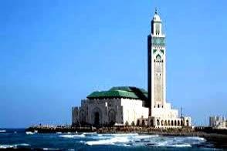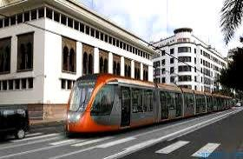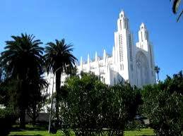
Touching hearts and minds…
Overnight in Fez
You will be able to visit a 17th century synagogue and have some time in the jewellery market.
a museum of Fez traditional arts.
In the afternoon visit to Royal palace of the late 19th century where the king Hassan I lived. This palace is now
founded in 857 ad. by a lady from Fez.
intricate architecture, and around the karaouine mosque which was once the oldest university in the world,
The highlight of your morning visit will be inside the 14th century Medersa (theological school) for its most
mosques and sanctuaries.
arts, visit the public bakeries and pastry makers in the residential quarters and see their historical fountains,
meet the school teacher and the pupils, enter artisan workshops and discover the secrets of their ancestral
markets, handicraft quarters, auction markets and colouful Souks. Visit the medieval children’s schools and
Fez will stimulate all your senses as you go for your guided tour inside Fes el Bali (old Fes) across food and spice
Start your day with a tour of the ramparts for a generous introduction to the history and the culture of the city.
city of the Arab world as it has preserved all its medieval aspects and way of life.
Fes is the oldest royal city in Morocco. Founded in the 9th century, it is said to be the most complete medieval
Day 2 : Full day of Fez
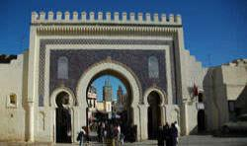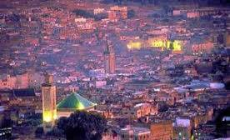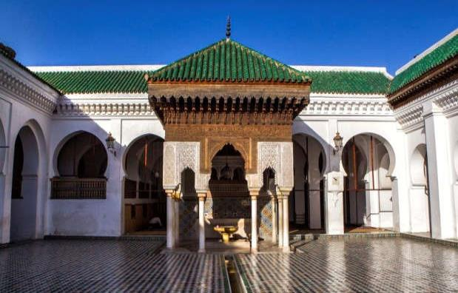
Touching hearts and minds…
Overnight in Marrakech.
city of Morocco.
palm trees of the oasis in the outskirts of Marrakech, you will know that you are not anymore far from the red
Many stops will be made along this itinerary for pictures, breaks for lunch. As soon as you start seeing the first
desert land areas in the winter.
tents and move with their herds of goats and sheep across these mountains in the hot season down to the
south offers a diversity of impressions through the Middle Atlas Mountains where nomad shepherds live in black
The road goes through magnificent cedar, pine and oak forests. This particularly varied itinerary from north to
resort, and Azrou, a typical Berber town with its flat roofed earth houses.
of Saiss up to Imouzzer de kandar with its nearby gorgeous lake ‘Dait Aoua’ and on to Ifrane, a charming ski
After an early breakfast in your hotel, leave Fez and head south drive crossing the cultivated and fertile valley
Day 3 : Fez to Marrakech via Beni Mellal
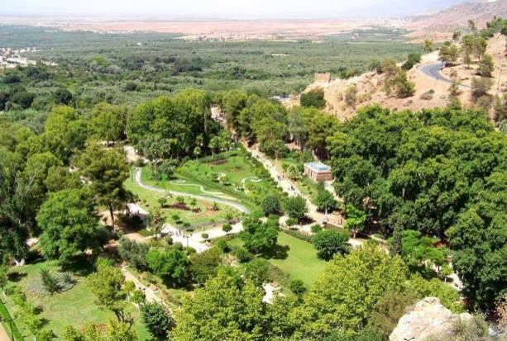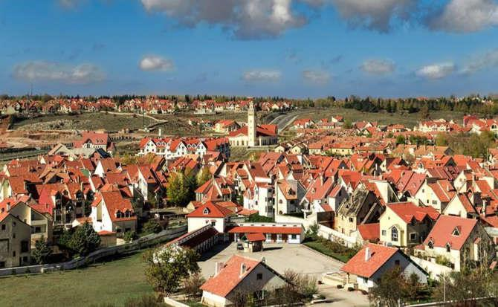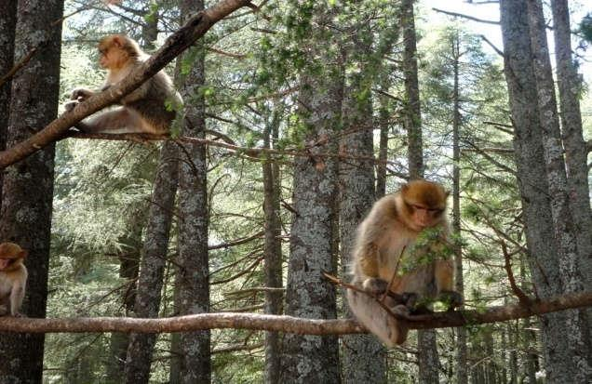
Touching hearts and minds…
their ancestral skills of making all sorts of local crafts.
traders. They are still in use today by Marrakech artisans who have set their workshops in many of them to perpetuate
Discover the hidden quarters and the historical caravanserai called Fondouks used once as hotels for the caravan
the early 12th century; a short time after the city was founded and became the capital of Morocco.
See the archaeological site of the Almoravid dynasty dome, which is the oldest monument in Marrakech dating back to
embroidery to ethnic jewelry and the fine blue and polychrome pottery.
admire besides the marvelous Moorish architecture, an interesting collection of antiques going from the art of
Visit a sumptuous Moorish palace that was once the home of a Moroccan minister until the end of the 19th century and
furnace that heats the public steam bath and learn the role they play in the social life of each quarter.
the Koran schools reciting verses, see old fountains, historical gates, visit an old bakery and taste the local bread, see the
We will make you cross some of the oldest quarters in the Medina of Marrakech. Along the way, we will hear children from
inhabitants and their daily occupations.
Start through one of the historical gates of the old Medina and walk to discover the medieval way of life of its
of the glorious past of this medieval capital of Morocco.
will see the traditional activities of the inhabitants of the old city and understand their way of life as well as some remains
This is an exciting and most interesting exploration of the deep and authentic side of the old city of Marrakech, where we
Day 4: AM Hidden sides tour of Marrakech.
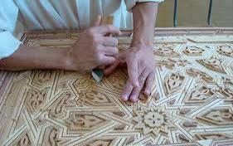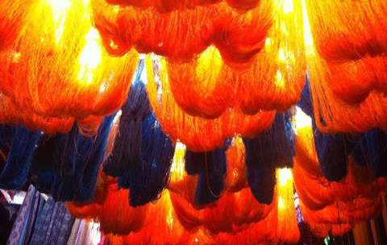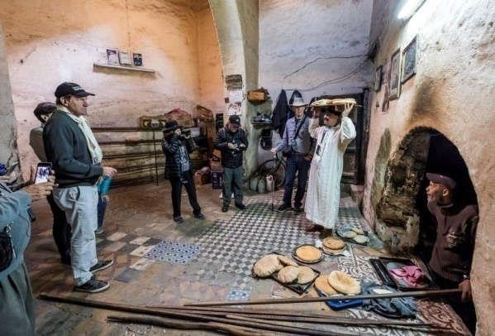
Touching hearts and minds…
Overnight in Marrakech.
clothing and 15,000 haute couture accessories.
at the same time as Yves Saint Laurent in Paris. The two museums will showcase a collection made up of 5,000 articles of
museum houses an important selection from the designer’s impressive art and design collection and was inaugurated
From here we will walk to Yves Saint Laurent Museum dedicated to his career’s artistic design and creation. This new
of Morocco and admire this marvelous treasures of local antiques. the visit.
displaying Yves Saint Laurent’s personal collection of Berber antiques to learn some fascinating facts about the Berbers
has been owned by the French designer, Yves Saint Laurent. We will visit the beautifully designed Berber museum
also more than 15 bird species that are endemic to North Africa and has an amazing collection of cacti. This garden
Art Deco villa of which the special shade of bold cobalt blue is named after the artist, ‘Majorelle blue’. The garden hosts
houses a collection of plants from the four corners of the world which flourish amidst elegant ornamental ponds and an
We take time for a stroll in the famous garden created by the orientalist painter Jacques Majorelle in 1920’s. The Garden
buildings, which are outstanding examples of Islamic art and architecture.
After lunch at the famous Le Jardin Secret in the heart of the Medina of Marrakech. And discover its gardens and
Day 4: PM Majorelle Garden & Yves Saint Laurent Museum
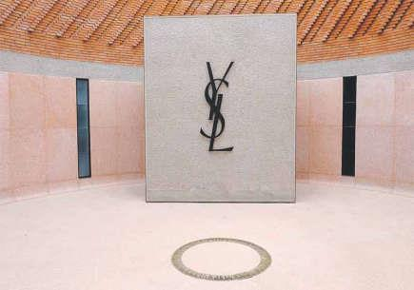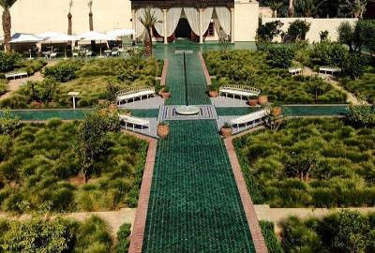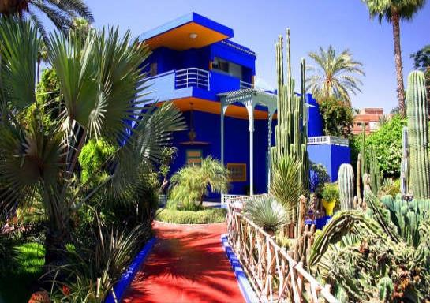
Overnight in Marrakech.
learn Arabic in preparation for big school. How’s yours coming on?
You’ll also meet the community’s youngest members at the charity pre-school centre where little Berbers
terraces to see the sweated labour that goes into ancient irrigation and subsistence farming methods.
weaving a colorful kilim with the local women behind their prized ancestral looms, and walk the farm
While lunch is simmering, get your hands stuck into wet clay in a ceramics workshop. Later, try your hand at
guide!
of traditional mint tea – made by you! The conversation should also start to flow, with a little help from your
Bake bread and prepare tagine in the kitchen of a village family and get to know them better over a pot
opening, hands-on adventure.
Valley and dramatic Atlas landscapes by luxurious SUV will be your only non-Berber experience on this eye-
Immerse yourself in the daily life of an authentic mountain community. The round-trip through lush Ourika
Day 5: Go Berber in the Atlas Mountains
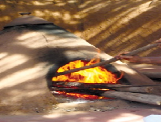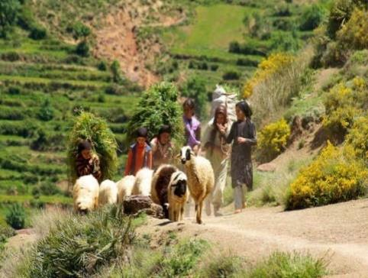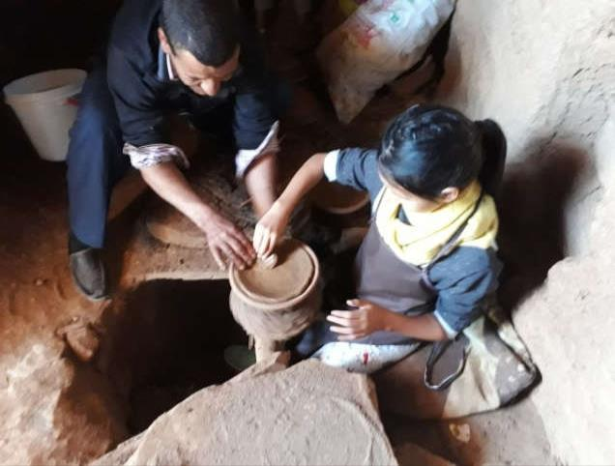
Overnight in Marrakech.
PM at leisure, enjoy the hotel facilities
entertainments and authentic activities.
We will end by exploring the famous square of Jemaa El Fna with our guide to discover the local
sounds of everyday life in this world of its own.
of the local spices and oils, touch the texture of the local fabrics, see the colorful markets and listen to the
This experience will offer us a feast for our senses as we will taste some local produce, smell the fragrance
A delightful walking tour inside the colorful Souks in the Medina of Marrakech.
Day 6: Experience the wonders of the souks
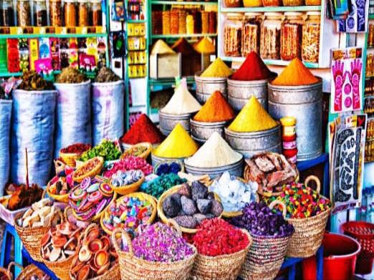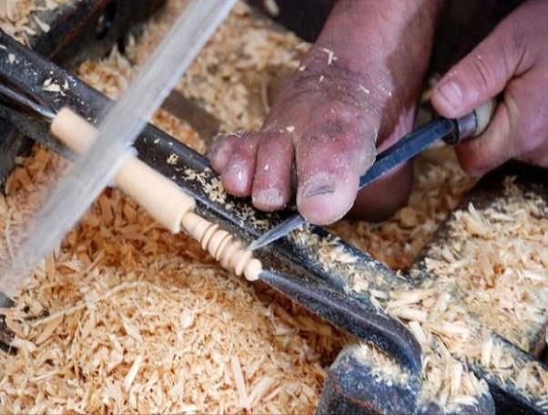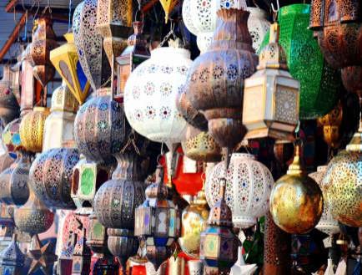
Touching hearts and minds…
flight.
After breakfast. Our tour leader will assure our transfer and assistance to the Casablanca airport for the return
Day 7: Departure
welcome you in Marrakech
We look forward to
Morocco, the country that travels within you…
We look forward to welcoming you
Morocco,The Country that Travels within you…
